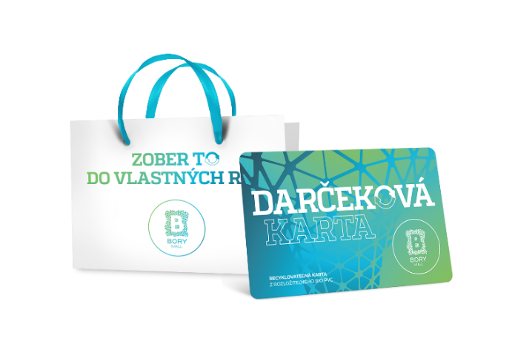
Zoznam prevádzok pre uplatnenie darčekových kariet Bory Mall od 25.2.2022

- A3 SPORT
- ALAIN DELON
- ALBI
- ALLTOYS
- ALPINE PRO
- ATTRACTIV
- BEPON
- BILLA
- BIOPARK
- BIOTECH USA
- BJÖRN BORG
- BLE BLE
- BLESK ČISTIAREŇ
- BLISK
- BRLOH
- BUPPI
- BURGER KING
- C&A
- CALLIOPE
- CALZEDONIA
- CCC
- CHICK´N CHEESE
- CILEK
- CINEMAX
- CROPP
- CURAPROX
- D´FASHION
- DATES MOBILE
- DEDOLES
- DELIKATESO
- DESIGUAL
- DH STORE
- DIVOKÁ KAČKA
- DM DROGERIE MARKT
- DORMEO HOME
- DOUBLE RED
- DR. MAX I., II.
- DRÁČIK
- ECCO
- EDO-KIN
- EIFFEL OPTIC
- EMPORIO ARMANI, DIESEL, CK
- ENDORPHIN REPUBLIC
- ERRORE
- ETA
- FANN PARFUMÉRIE
- FAVAB
- FAX COPY
- FITPLUS
- FIXSERVIS
- FRESH BBQ
- FRUITISIMO
- FUSAKLE
- GANT
- GATE
- GOLD BARBERSHOP
- GOLD POINT
- GOLEM
- H&M, H&M HOME
- HELLY HANSEN
- HOUSE
- HUMANIC
- HUMMUS AND COUSCOUS BAR
- INTERSPORT
- INTIMISSIMI
- iSTYLE
- IQOS
- JOLLEO
- JULIUS MEINL
- KARA
- KFC
- KLIER
- KNIP
- KOLIBA
- KOMPOT
- KOŠELE...
- KUBU
- LARA BAGS
- LARA BEAUTY
- LEVI'S, MUSTANG
- LINDEX
- LITTLEONE
- LOTSI SILVER
- MANUFAKTURA
- MATERASSO
- MCDONALD'S
- MEATFLY
- MEDIAPRESS TRAFIKA I., II.
- MICHELL
- MI STORE
- MOBILE OUTFITTERS
- MOHITO
- MONDIEU
- MUZIKER
- NATACHA PACAL PATISSERIE
- NATURHOUSE
- NAY
- NOODLES BY YAN
- O2
- OFFICE SHOES
- OPTIKA FRÖHLICH
- OPTIKA MANIA
- ORANGE
- ORION
- ORSAY
- OUTDOOR GUIDE
- OXALIS
- OZETA
- PANTA RHEI
- PARTYLAND
- PEPCO
- PHO
- PIZZA HUT
- PLAYGOSMART
- PRESPÁNOK
- PRIMADONNA COLLECTION
- PUPA
- PÚPAVA DETSKÁ OBUV
- RESERVED
- RHAPIS
- s.OLIVER
- SAMSONITE
- SAMSUNG
- SATYAM
- SCAN QUILT
- SEDRYK LE BLANC
- SINSAY
- SOFIA
- SPORTISIMO
- SPORTS DIRECT
- STARBUCKS
- STARÝ OTEC
- SUBWAY
- SUPER ZOO
- SWAROVSKI
- ŠEVT
- TAKKO FASHION
- TEDI
- TERRANOVA
- TESCOMA
- THE GRILL
- THE WAFFLE
- TCHIBO
- TETA DROGÉRIA
- TIME OUT DETSKÝ KÚTIK
- TITI PAPIERNICTVO
- TOP FUN
- TOP SERVICE
- TRAPPER
- TUI REISECENTER
- UNCS
- VNÍMAVÉ DETI
- YAKUZA
- YOGI'S COFFEE STATION
- YVES ROCHER
- WOMAN´S
- WRANGLER, LEE
- ZEISS VISION CENTER

